# Eco. Enviro.

The capital markets

provide a mechanism to help our economy allocate resources efficiently.

Corporations

acquire capital from investors in exchange for ownership interest and from creditors by borrowing.

Initial market transactions

involve issuance of stocks and bonds by the corporation.

Secondary market transactions

involve the transfer of stocks and bonds between individuals and institutions.

# Cash flow perspective

Investors and creditors are interested in earning a fair return on the resources they provide

The expected rate of return and the uncertainty, or risk, of that return are key variables in the investment decision.

A company will be able to provide a return to investors and creditors only if it can generate a profit from selling its products or services.

The objective of financial accounting is to provide investors and creditors with useful information for decision making.

# Cash V.S. Accrual Accounting

Cash basis:

Net operating cash flow, difference between cash receipts and cash payments from transactions, from providing goods and services.

However, over short periods of time, operating cash flow may not be an accurate predictor of future operating cash flows.

Accrual Accounting is a better way to predict future cash flow

Net income is the difference between revenues and expenses.

Net income is considered a better indicator of future operating cash flows than is current net operating cash flow.

The accrual accounting model provides a measure of periodic performance called net income, the difference between revenues and expenses.

# Reporting Standards

GAAP (generally accepted accounting principles)

A dynamic set of both broad and specific guidelines that companies should follow when measuring and reporting the information in their financial statements and related notes

Historical Perspective and Standards

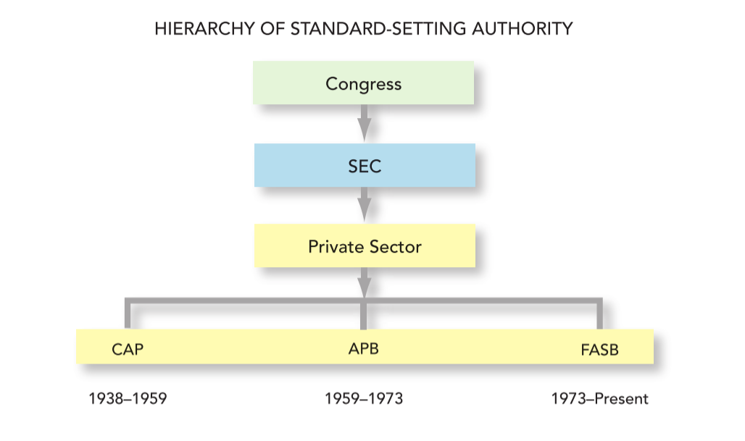

Compare GAAP and IFRS

|  |  |  |
| --- | --- | --- |
|  | U.S. GAAP | IFRS |
| Regulatory oversight provided by:  Foundation providing oversight, appointing members, raising funds:  Standard-setting board:  Advisory council providing input on agenda and projects:  Group to deal with emerging issues: | Securities Exchange Commission (SEC)  Financial Accounting Foundation (FAF): 20 trustees  Financial Accounting Standards Board (FASB): 7 members  Financial Accounting Standards Advisory Council (FASAC): 30–40 members  Emerging Issues Task Force (EITF): 15 members | International Organization of Securities Commissions (IOSCO) *  International Accounting Standards Committee Foundation (IASCF): 22 trustees    International Accounting Standards Board (IASB): 16 members  Standards Advisory Council (SAC): 30–40 members  International Financial Reporting Interpretations Committee (IFRIC): 14 members |

# The Standard-Setting Process

DUE PROCESS.

1The Board identifies financial reporting issues based on requests/recommendations from stakeholders or through other means.

2The Board decides whether to add a project to the technical agenda based on a staff-prepared analysis of the issues.

3The Board deliberates at one or more public meetings the various issues identified and analyzed by the staff.

4The Board issues an Exposure Draft. (In some projects, a Discussion Paper may be issued to obtain input at an early stage that is used to develop an Exposure Draft.)

5The Board holds a public roundtable meeting on the Exposure Draft, if necessary.

6The staff analyzes comment letters, public roundtable discussion, and any other information. The Board redeliberates the proposed provisions at public meetings.

7The Board issues an Accounting Standards Update describing amendments to the Accounting Standards Codification.

# The Role of the Auditor

Auditors offer credibility to financial statements.

Auditors express an opinion on the compliance of financial statements with GAAP.

Certified public accountants (CPAs) are licensed by states to provide audit services.

# Besides Rule based standard

A principles-based, or objectives-oriented, approach to standard- setting stresses

professional judgment, as opposed to following a list of rules.

Ethics deals with the ability to distinguish right from wrong.

# Accounting Cycle

